Watford Borough Council: Margaret Maughan commission

Public Art Commission
Artist’s Brief & Request for Proposal
1. The Project
Watford Borough Council seeks to commission a permanent public artwork in honour of the late Margaret Maughan—Great Britain’s first-ever Paralympic gold medallist and a long-term Watford resident. The artwork will celebrate Margaret’s remarkable life, achievements, and legacy while contributing to the cultural and visual identity of the new Riverside development in Watford.
The council welcomes designs in all style. We encourage artists to bring their own style, concepts, and creative voice to the project. Although a simple direct figurative or formalist representation is not the ideal representation we are looking fo, it is also not discouraged. Artists are invited to consider innovative ways of expressing Margaret’s story, values, and contributions through thoughtful visual language.

2. Background
Margaret Maughan (1928–2020) made history at the 1960 Paralympic Games in Rome, becoming Great Britain’s first Paralympic gold medallist by winning the Columbia Women’s Round Open in archery. She further secured a second gold medal in the Women’s 50m Backstroke Complete Class 5, where she was the sole competitor. Over her lifetime, Margaret became an enduring symbol of resilience, athletic excellence, and pioneering spirit.
Margaret lived most of her life in Watford, and the commissioned artwork aims to honour her connection to the town and her groundbreaking role in British sporting history. In 2012 she lit the Paralympic flame in London.

3. About the Riverwell Development
Riverwell is transforming former industrial, contaminated land near Watford town centre into a thriving mixed-use neighbourhood. It includes:
New homes, including affordable housing (560 already delivered, with 700 more planned)
Residential, commercial, office, leisure, retail, industrial, and community spaces delivered as part of a long-term masterplan.
Major infrastructure improvements, including a hospital access road and a 1,455‑space multi-storey car park serving Watford General Hospital
A new primary school, retirement village, hotel, and landscaped public parks forming part of its mixed-use offer.
Regeneration of the River Colne, the creation of green open spaces, and improved cycle and pedestrian routes.
Overall, Riverwell is envisioned as a vibrant, sustainable riverside community, blending housing, public amenities, retail, leisure, nature, and employment uses within one unified development.
The exact installation site for the artwork will be confirmed collaboratively with the council and the appointed artist to ensure a harmonious relationship with this evolving environment.

4. The Area / Location
The artwork will form part of the Watford Riverwell development—one of the largest and most significant regeneration projects in the town’s history. Riverwell is a 20-year, 70-acre redevelopment jointly delivered by Watford Borough Council and Kier Property.
Location here: https://maps.app.goo.gl/mecTM2YqKPBe9hy68
The artwork will sit within the new public square; in a quiet, reflection space within the trees as circled in the CGI and plan below -

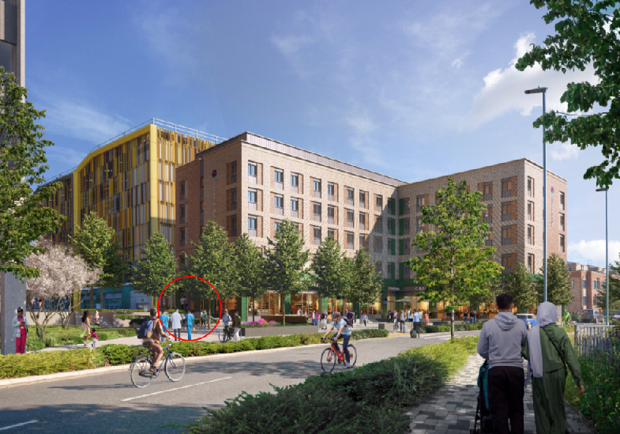
Watford General Hospital
Public square
Travel lodge hotel
Multi-storey Car Park / retail units to ground floor
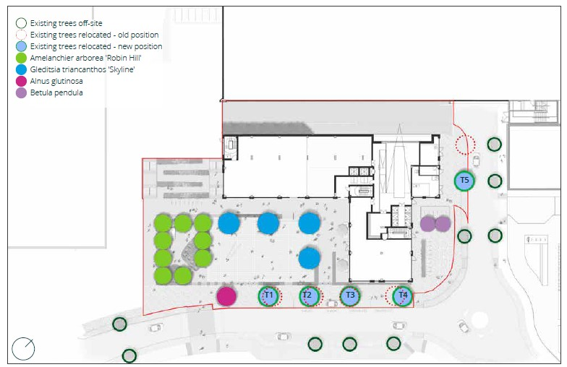
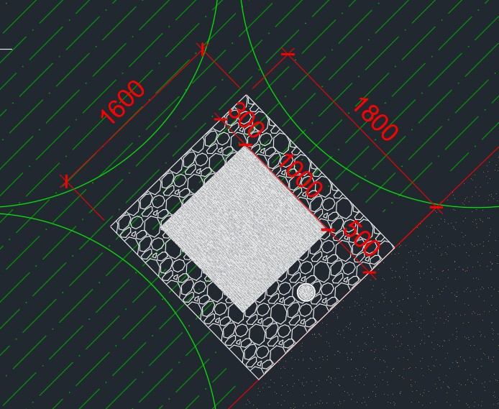
It will be in set within a bordered shingle area measuring 1.6x1.8m – see snapshot above.
The artwork will be surrounded by semi established trees.

5. Approach / Specific Requirements
Watford Borough Council seeks proposals that demonstrate:
Artistic Direction
- The art piece must be a maximum of 1m x 1m footprint and can be up to 2m high. If a plinth above ground level is required then this should be treated as part of the artwork.
- A less formalistic or more conceptual approach to honouring Margaret Maughan’s life and achievements.
- A clear artistic vision demonstrating sensitivity, creativity, and originality.
- An understanding of Margaret’s impact both locally and nationally.
Practical Considerations
- The use of sustainable practices, including locally sourced or low-impact materials where feasible.
- Demonstrable experience in producing durable public artworks suitable for permanent outdoor environments.
- The ability to collaborate with a council-appointed board for design development.
- Capacity to manage fabrication, installation, and project delivery.
- The submission must consider the implications of installation and provide information on how the piece is to be fixed and into what foundation / base.
- Consider maintenance in the event of damage or acts of vandalism.
Professional Requirements
- Public liability insurance.
- An up-to-date DBS check.
- Proven track record in delivering public art commissions or similar projects.
Submission Requirements
Initial applications should include:
- A short-written concept proposal
- Up to three initial design sketches or visualisations
- Examples of relevant past work
- A brief artist CV or biography
Shortlisted artists will be invited to present their concepts to a council-selected representation board. Travel costs and modest time expenses will be covered for this stage, this is only for those who are shortlisted and invited to present.
6. Tender Evaluation
The Tender process will be conducted to ensure that Tenders are evaluated fairly to ascertain the most economically advantageous tender.
Award Criteria
Artists response to the questions contained in Table 1 along with their pricing information and any other information, specifically related to the evaluation of Tenders will be evaluated against all of the following criteria.
The tender Award Criteria are as follows:

Table 1 - Award Criteria
Criteria | Percentage weightings
Quality | 60%
1. Method statement  Describe how you will approach and deliver this project including:  • Please outline how you combine quality, health and safety and environmental management into the project delivery.  • Outline roles and responsibilities of all key staff involved in delivering the project.  • Describe how you will ensure this project is delivered on time and in budget  •Detailed delivery method – setting out how it will be manufactured and how it will be installed | 15%
2. Sketches and outline of Offer  We will be looking at:  • Quality and depth of the proposed approach to the commission, such as understanding of the commission and wider project.  • Initial drawing(s) of piece(s) with initial idea on measurements (not expected to scale at this stage).  • Understanding of where the piece(s) will be placed and how it will fit into the area(s).  • Why the style of the piece has been chosen.  • Explanation of any symbolism/wording.  Any historical or contextual information on or around the piece(s) or approach.  • How you have considered the brief - in honour of the late Margaret Maughan—Great Britain’s first-ever Paralympic gold medallist and a long-term Watford resident | 25%
3. Supply Chain and Social  • Please detail any opportunities for local collaboration, local and ethical procurement of materials and the accessibility of your process and/or piece.  • Or evidence of where social value has been implemented of projects of the same or similar size which you have previously worked on.  • Community Engagement | 10%
3. Experience  Provide evidence of three projects of the same or similar scale and content that you have completed in the past 5 years. Your submission should include:  •Description of the works/Client brief  •Client details  •Contract value  •Programme  •Provide details of previous contracts  •Evidence of satisfactory completion  •Provide reference details for at least three projects, including contact information | 10%
Presentation & Interview | 40%
Total | 100%

Please note applicants will not be scored on cost

Shortlisted applicants – scoring a minimum of 30% will be notified in writing and invited in to present to their further developed concept ideas to the Council Board.
Shortlisted applicants will receive:
- Reimbursement for travel
- A contribution towards time spent preparing and presenting their design development
The successful applicant from the pool of shortlisted artists will then enter into a contract with the council.

7. Budget
The total budget for the commission (inclusive of artist fees, materials, fabrication, installation, travel, insurance, and VAT where applicable) is £50,000 to take this project from design through to installation.
We require a detailed cost breakdown and payment timetable.

8. Timeline
A more detailed schedule will be provided, but the anticipated timeline is as follows:
- Call for artists issued: 29 May 2026
- Close of requests for further clarifications: 19 June 2026
- Deadline for initial proposals: 6 July 2026
- Shortlisting period closed by: 10 July 2026
- Applicant’s presentations to the council board: week commencing 3 August 2026
- Artist appointment: 7 August 2026
- Design development and refinement: 30 September 2026
- Fabrication and installation: 18 December 2026
- Artwork unveiling: To align with Riverside development milestones
Watford Borough Council will work closely with the appointed artist to ensure milestones are achievable and well supported.

For further clarifications please contact:
Sarah McKenzie - sarah.mckenzie@watford.gov.uk | 01923 278056
Regeneration Project Manager | Place

